

Name : Bisma Fatima

Class : CS-24-A

Roll No : F24605036

Course : Object oriented programming

Code : CS-123

Lecturer : Ma’am Tayyaba kalsoom

Post lab task week 01

Qno 01
Write a program that asks the user for an integer. Determine if the number is positive, negative, or zero. Print the result.
PROGRAM
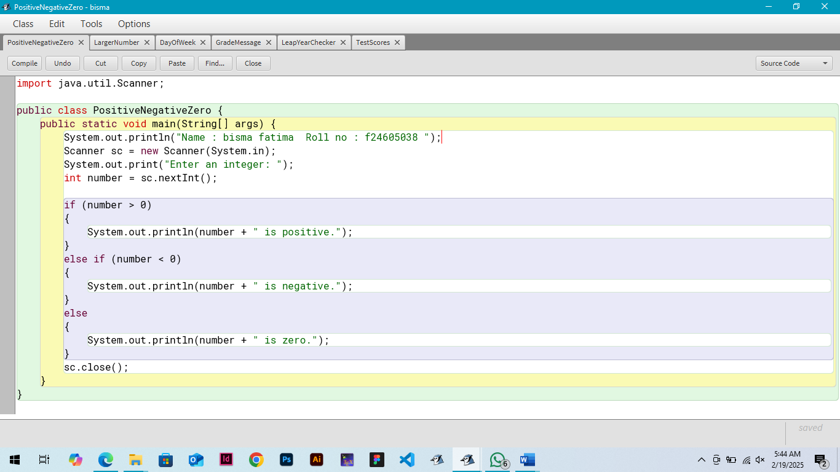
OUTPUT
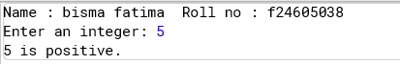

QNO 02
Write a program that asks the user for two integers. Use the conditional operator to determine and print the larger of the two numbers.
PROGRAM
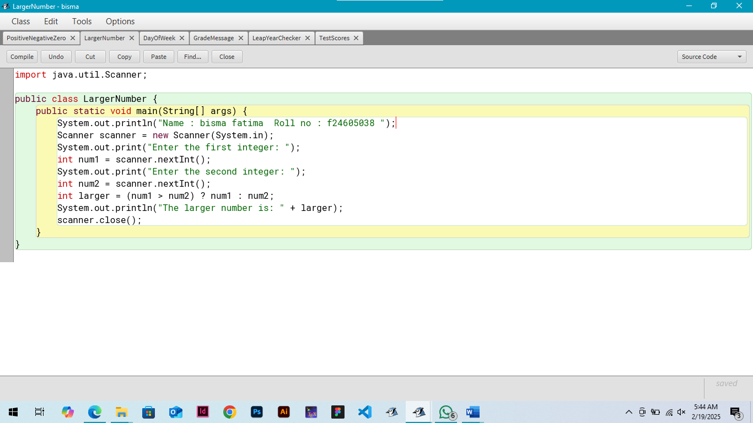
OUTPUT
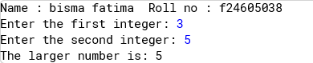
QNO 03
Write a program that asks the user for a day of the week (e.g., "Monday," "Tuesday," etc.). Use a switch case statement to print a message indicating whether it's a weekday or a weekend.
PROGRAM

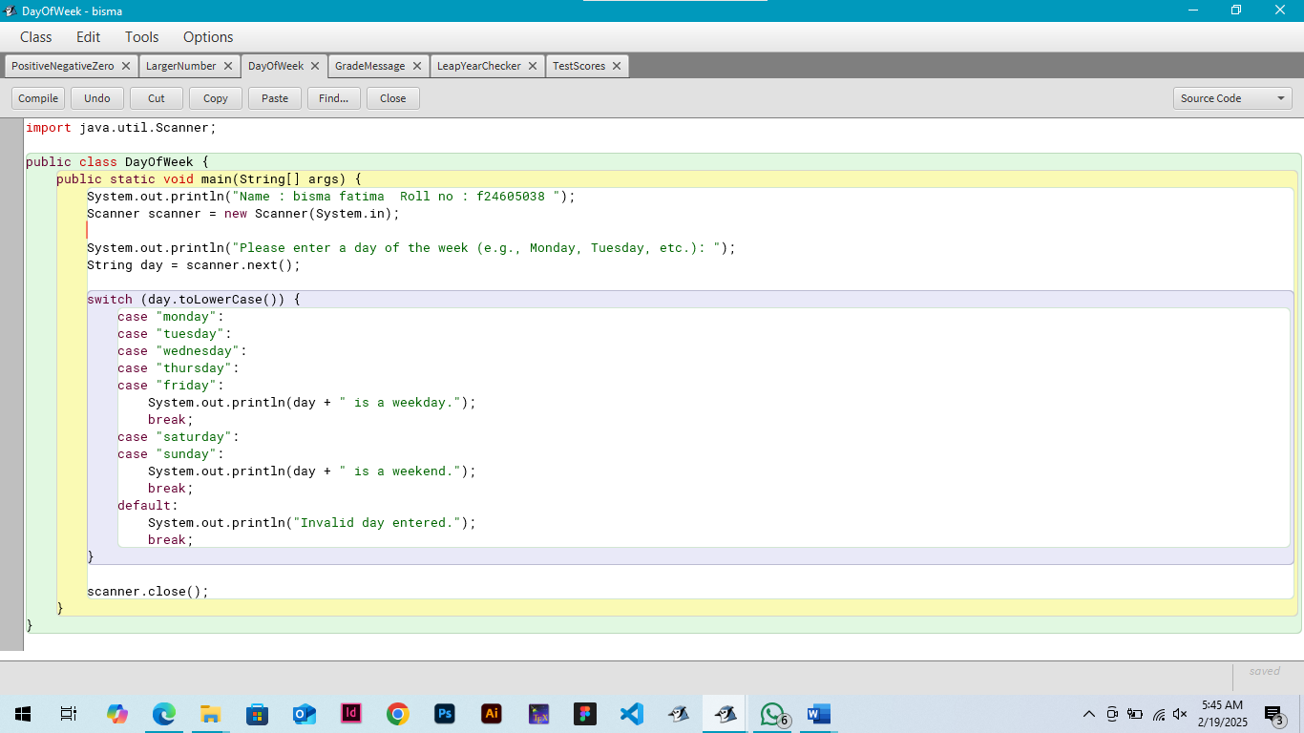
OUTPUT
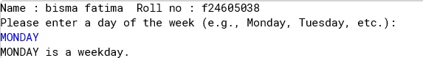
QNO 04
Write a program that asks the user for their grade (A, B, C, D, or F). Use a switch case statement to print a message based on the grade:
- A: "Excellent!"
- B: "Good job!"
- C: "Fair."
- D: "Needs improvement."
- F: "Failing." If the user enters an invalid
grade, print an error message.

PROGRAM
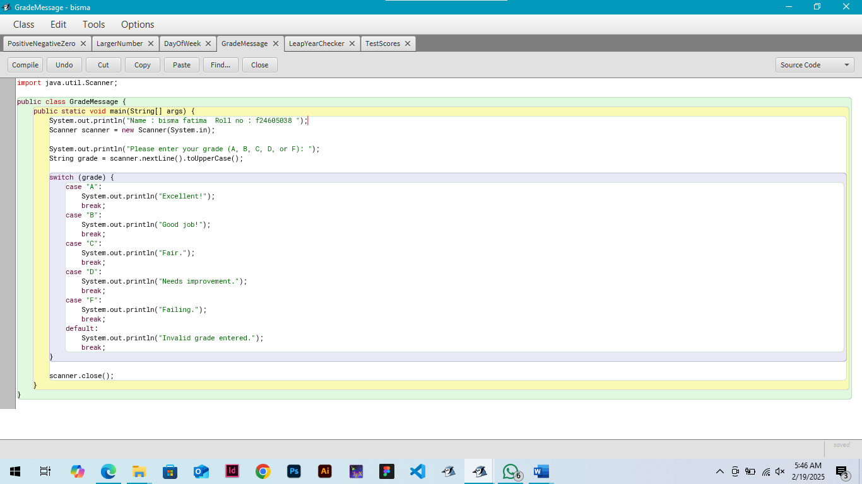
OUTPUT
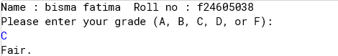
QNO 05
Ask the user for a year. Determine if it is a leap year. Print the result. (A leap year is divisible by 4, but not by 100, unless it is also divisible by 400).
PROGRAM
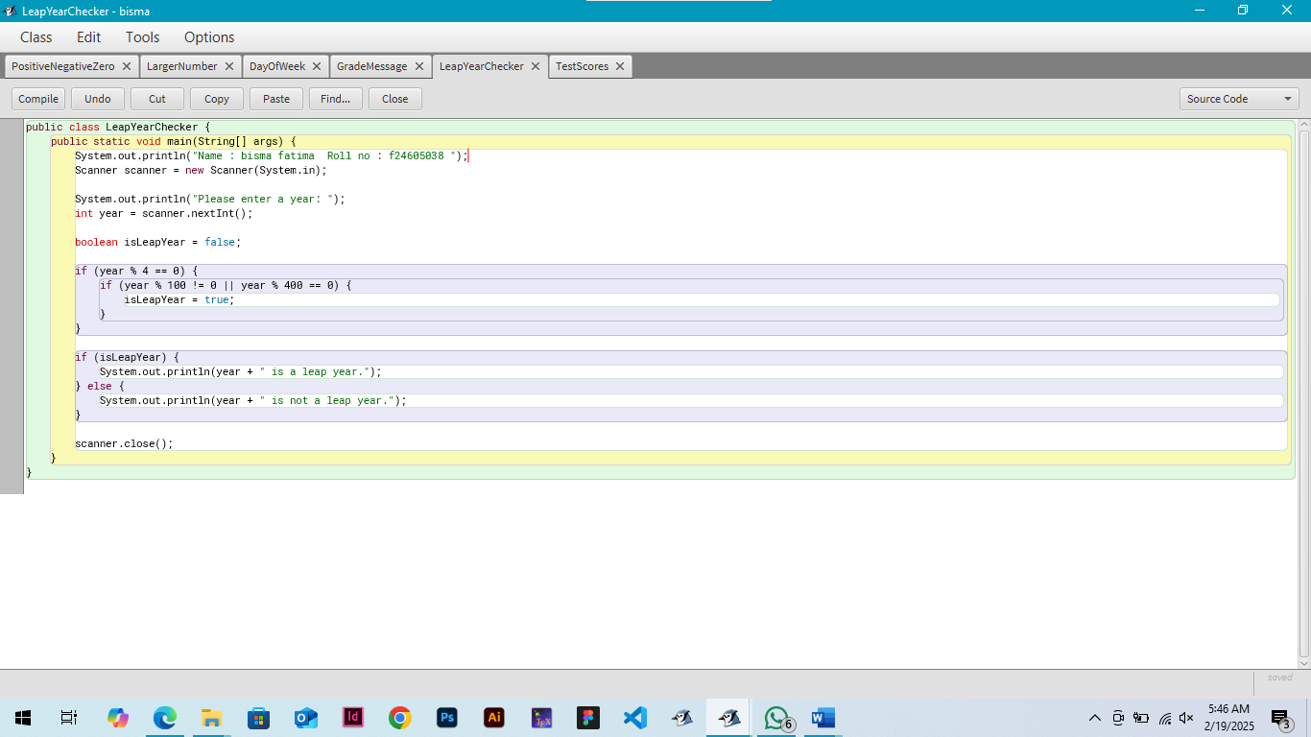
OUTPUT
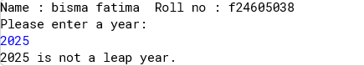
QNO 06
Ask the user for their scores on three tests (out of 100). Calculate the average score and assign a letter grade based on the following scale:
- 90-100: A
- 80-89: B
- 70-79: C
- 60-69: D
- Below 60: F

PROGRAM
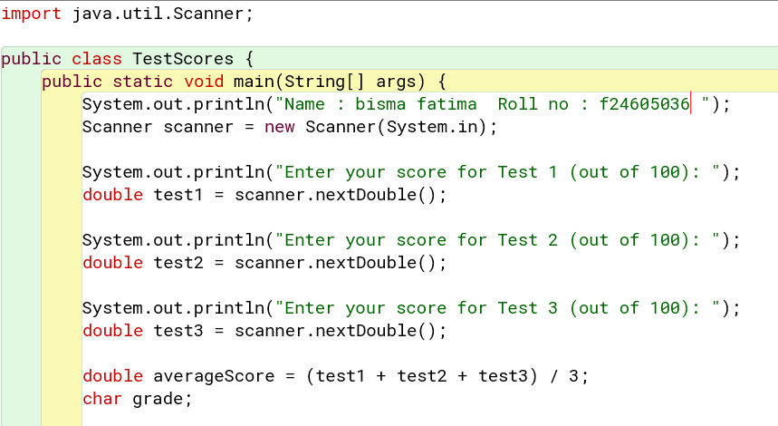

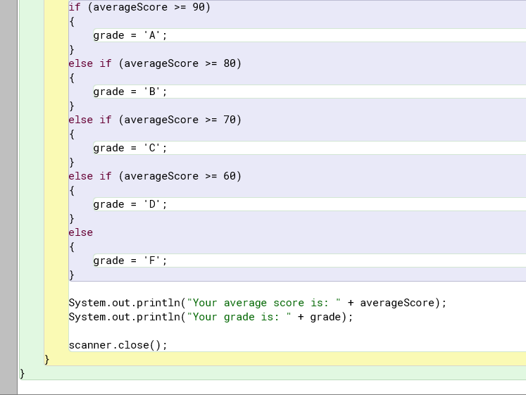
OUTPUT
